Step 3: Quality Check Subcortical Volumes (FSL FIRST)
Highlighted portions of the instructions may require you to make changes so that the commands work on your system and data.
This section assumes that you have installed:
- SurfScan (http://ibowman.com/surfscan/) for the computing platform of your choice
- Matlab (and download a few scripts called QC_ENIGMA.tar.gz here)
  - For those groups that do not have access to Matlab, Roberto Toro has written a QC application in Java that should work across platforms without relying on any external applications (like Matlab). It is confirmed to work on Mac computers, but should work on any platform with the JVM available. Please contact Roberto Toro and Derrek Hibar if you are interested. Also it is possible to perform QC of your images in FSLView using a “for” loop to open up each of your segmented images files.
For FSL FIRST users:
Change directories to the folder where all of the FIRST segmentation output is stored.
cd /enigma/first/data/
We need to get all of the FSL FIRST segmentation labels into standardized space in order to do QC more efficiently. To do this we can run this quick for loop (should take approx. 1 minute/subject):
bash
for subj_id in subj*.nii; do #change to the pattern that selects the filenames of your original MRIs
subj_id_nosuffix=`$FSLDIR/bin/remove_ext ${subj_id}`
flirt -in ${subj_id_nosuffix}_first12_all_fast_firstseg.nii.gz -ref $FSLDIR/data/standard/MNI152_T1_1mm_brain -out ${subj_id_nosuffix}_first12_all_fast_firstseg_std.nii.gz –interp nearestneighbour -init ${subj_id_nosuffix}_to_std_sub.mat -applyxfm
done

##################################################################
##################################################################

Change directories to the folder with the required Matlab *.m scripts. For simplicity, we assume you are working on a Linux machine with the base directory /enigma/QC_ENIGMA/.
Start Matlab: /usr/local/matlab/bin/matlab
Add the current folder containing all of the required scripts to Matlab’s path.
Select: File -> Set Path -> Add Folder -> {OK} -> {Save} -> {Close}
In the Matlab console window change directories to the folder with all of your FSL FIRST segmentation data.
cd /enigma/first/data/
Make a directory to store all of the QC output.
mkdir /enigma/first/QC/
The script we want to run is called make_pngsFSL.m with the following parameters:
make_pngsFSL(output_directory, subject_name, select_segmentations_image, select_mri_image)
We want to set ‘subject_name’ such that ‘subject_name’ + ‘select_segmentations_image’ will form the full name of the registered segmentation label files we just made with flirt (e.g. subj1_brain_first12_all_fast_firstseg_std.nii.gz) and similarly for ‘select_mri_image’ we want it to give the full name of the registered MRI scan outputted by FIRST (e.g. subj1_brain_ to_std_sub.nii.gz).
In Matlab we can do:
a=dir('subj*.nii'); %Choose this so that it selects
%your original subject MRI files
for x = 1:size(a,1)
[c,b,d]=fileparts(a(x,1).name);
%if your original data files are in .nii.gz format you need
%to remove both extensions
%uncomment this next command to do it
%[c,b,d]=fileparts(b);
try
make_pngsFSL('/enigma/first/QC/', b, ['/enigma/first/data/', b, '_to_std_sub.nii.gz'], ['/enigma/first/data/', b, '_first12_all_fast_firstseg_std.nii.gz']);
end
display(['Done with subject: ', num2str(x), ' of ', num2str(size(a,1))]);
end
%Note that you may have to change '_to_std_sub.nii.gz'
% or '_first12_all_fast_firstseg_std.nii.gz' if
% Your files are named following a different convention

The make_pngFSL script should take approximately 5 minutes/subject and will output a series of *.png image files separated by individual subject folders.
##################################################################
SurfScan
##################################################################
Once you are done generating images for each of your files it is time to start doing QC! Using the SurfScan program, quality checking each of your images is really simple and can be completed quickly.
First we need to generate a SurfScan formatted file to tell the program where to find each of the images. We can do this using the included script. Also we need to give the script a list of the subject folder names created with the Matlab script. If we change directories to our QC output folder we can store the directory names in a text file like this:
ls -d * >> subjects.txt
Then we can run the script to make the SurfScan formatted files:
/enigma/QC_ENIGMA/make_ENIGMA_sscfiles.sh /enigma/first/QC/ \ subjects.txt
This script should take only about 30 seconds to complete. It will output a series of SurfScan formatted files in your QC output directory called: All_ROIS.ssc, Accumbens.ssc, Amygdala.ssc, Caudate.ssc, Hippocampus.ssc, Pallidum.ssc, Putamen.ssc, and Thalamus.ssc.
Now we can open the SurfScan program to perform the QC:
/enigma/local/surfscan
Type -> “O”
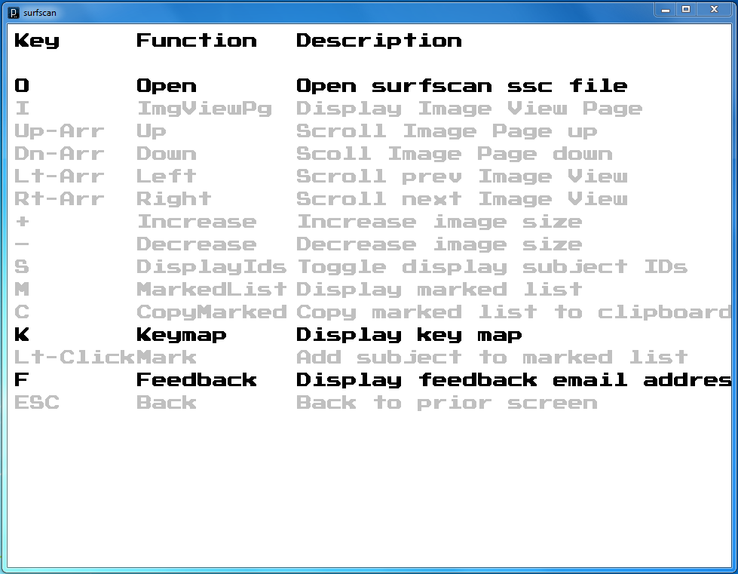
Locate one of the .ssc files we just created in the QC output folder /enigma/first/QC/. For example, let’s look at Caudate.ssc.
Having Problems? Note 1: When opening a new .ssc file in SurfScan the program first checks to see if all of the files specified exist. Sometimes the FIRST segmentations completely fail or another error occurs and the Matlab script creates a folder for a subject but does not include any output. SurfScan will fail to open the .ssc file and will instead list the problem files. You should check out any problem subjects and remove them from your LandRvolumes.csv file if there are any serious errors. Also, you need to remove the subject’s folder from the QC folder, generate a new subjects.txt file (by dropping the problem subject), and rerun the make_ENIGMA_sscfiles.sh script.
Having Problems? Note 2: Ideally, you should be using SurfScan on the same OS platform where your data are stored. However, it is definitely possible to view your images on a Windows machine when your data are stored on a Linux server, for example. You do need to make sure that your Linux server is mapped on your Windows machine and edit the path in the .ssc files to point to the location of your subject folders for QC.

You can increase the size of each individual picture so that they are easier to see:
Type -> “Ctrl” and “+” or “Shift” and “+”
To overlay the subject ID info
Type -> “s”
Pressing the “Down” or “Up” arrow on the keyboard scrolls through each of your subjects. Using the “Left” and “Right” arrow takes you to a new slice view for that same set of subjects.
If you open the LandRvolumes.csv file we created in Step 2 in your favorite spreadsheet software (e.g. Microsoft Excel), you can find any bad subjects and mark either its left or right Caudate value with an “x” <-(lower or upper case X is fine).
Note: You can determine the laterality (left or right) in your image by referencing the color of the label. The red label indicates the RIGHT structure and the blue label indicates the LEFT.
Repeat this process for the remaining 6 structures and save the LandRvolumes.csv file for use in the association testing steps.
Figure 1:
