Step 3: Quality Check Subcortical Volumes (for FreeSurfer)
Highlighted portions of the instructions may require you to make changes so that the commands work on your system and data.
This section assumes that you have installed:
- SurfScan (http://ibowman.com/surfscan/) for the computing platform of your choice
- Matlab (and download a few scripts called QC_ENIGMA.zip here)
  - For those groups that do not have access to Matlab we have a compiled version of our scripts that do not require a Matlab license. Currently, we only have the compiled version setup for Linux x64 bit architectures, but we can compile for other platforms if necessary (Please contact Derrek Hibar). Also it is possible to perform QC of your images in FSLView using a “for” loop to open up each of your segmented images files.
For FreeSurfer users:
Assuming that you have downloaded the collection of Matlab scripts found at http://enigma.ini.usc.edu/wp-content/uploads/2015/06/QC_ENIGMA.zip, change directories to the folder with the required Matlab *.m scripts. For simplicity, we assume you are working on a Linux machine with the base directory /enigma/QC_ENIGMA/.
Start Matlab: /usr/local/matlab/bin/matlab
Add the current folder containing all of the required scripts to Matlab’s path.
Select: File -> Set Path -> Add Folder -> {OK} -> {Save} -> {Close}
In the Matlab console window change directories to the folder with all of your FreeSurfer subject folders.
cd /enigma/subjects/
Make a directory to store all of the QC output.
mkdir /enigma/subjects/QC/
The script we want to run is called make_pngsFS.m with the following parameters:
make_pngsFS(output_directory, subject_name, select_segmentations_image, select_mri_image)
We want to set ‘subject_name’ such that ‘subject_name’ + ‘select_segmentations_image’ will form the full name of the registered segmentation label files (e.g. subj1/mri/aseg.mgz) and similarly for ‘select_mri_image’ we want it to give the full name of the registered MRI scan outputted by FreeSurfer (e.g. subj1/mri/brainmask.mgz).
In Matlab we can do:
a=dir('subj*'); %Choose this so that it selects only your
%subject folders that contain FS output
for x = 1:size(a,1)
[c,b,d]=fileparts(a(x,1).name);
try
make_pngsFS('/enigma/subjects/QC/', b, ['/enigma/subjects/', b, '/mri/brainmask.mgz'], ['/enigma/subjects/', b, '/mri/aparc+aseg.mgz']);
end
display(['Done with subject: ', num2str(x), ' of ', num2str(size(a,1))]);
end

The make_pngFS script should take approximately 5 minutes/subject and will output a series of *.png image files separated by individual subject folders.
##################################################################
SurfScan
##################################################################
Once you are done generating images for each of your files it is time to start doing QC! Using the SurfScan program, quality checking each of your images is really simple and can be completed quickly.
First we need to generate a SurfScan formatted file to tell the program where to find each of the images. We can do this using the included script. Also we need to give the script a list of the subject folder names created with the Matlab script. If we change directories to our QC output folder we can store the directory names in a text file like this:
ls -d * >> subjects.txt
Then we can run the script to make the SurfScan formatted files:
/enigma/QC_ENIGMA/make_ENIGMA_sscfiles.sh /enigma/first/QC/ \ subjects.txt
This script should take only a few seconds to complete. It will output a series of SurfScan formatted files in your QC output directory called: All_ROIS.ssc, Accumbens.ssc, Amygdala.ssc, Caudate.ssc, Hippocampus.ssc, Pallidum.ssc, Putamen.ssc, and Thalamus.ssc.
Now we can open the SurfScan program to perform the QC:
/enigma/local/surfscan
Type -> “o”
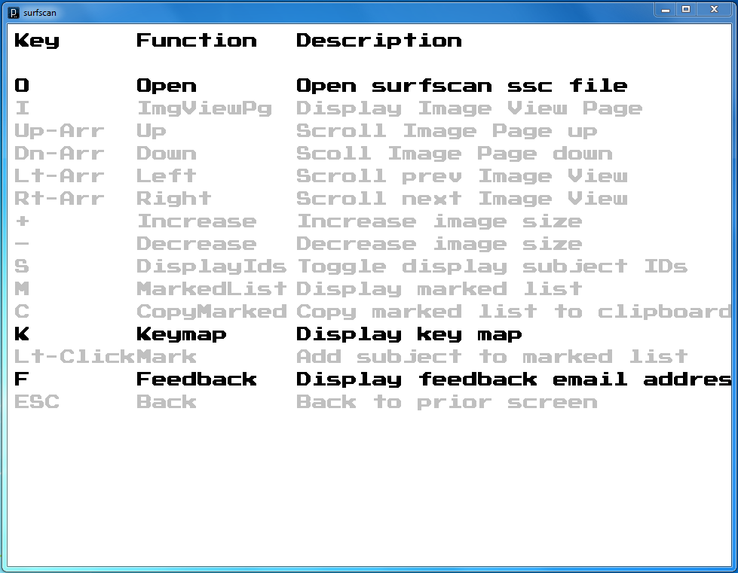
Locate one of the .ssc files we just created in the QC output folder /enigma/first/QC/. For example, let’s look at Caudate.ssc.
Having Problems? Note 1: When opening a new .ssc file in SurfScan the program first checks to see if all of the files specified exist. Sometimes the FreeSurfer segmentations completely fail or another error occurs and the Matlab script creates a folder for a subject but does not include any output. SurfScan will fail to open the .ssc file and will instead list the problem files. You should check out any problem subjects and remove them from your spreadsheet containing all of your extracted subcortical volumes if there are any serious errors. Also, you need to remove the subject’s folder, generate a new subjects.txt file, and rerun the make_ENIGMA_sscfiles.sh script.
Having Problems? Note 2: Ideally, you should be using SurfScan on the same OS platform where your data are stored. However, it is definitely possible to view your images on a Windows machine when your data are stored on a Linux server, for example. You do need to make sure that your Linux server is mapped on your Windows machine and edit the path in the .ssc files to point to the location of your subject folders for QC.

You can increase the size of each individual picture so that they are easier to see:
Type -> “Ctrl” and “+” or “Shift” and “+”
To overlay the subject ID info
Type -> “s”
Pressing the “Down” or “Up” arrow on the keyboard scrolls through each of your subjects. Using the “Left” and “Right” arrow takes you to a new slice view for that same set of subjects.
If you open the LandRvolumes.csv file we created in Step 2 in your favorite spreadsheet software (e.g. Microsoft Excel), you can find any bad subjects and mark either its left or right Caudate value with an “x” <-(lower or upper case X is fine).
Note: You can determine the laterality (left or right) in your image by referencing the color of the label. The red label indicates the RIGHT structure and the blue label indicates the LEFT.
Note for FreeSurfer Users: In some cases where images were segmented with older versions of FreeSurfer (i.e. <v4) the QC images generated in Matlab can sometimes produce images with colored pixels scatter around the image. These additional pixels can be safely ignored.
Repeat this process for the remaining 6 structures and save the LandRvolumes.csv file for use in the association testing steps.
Figure 1.
